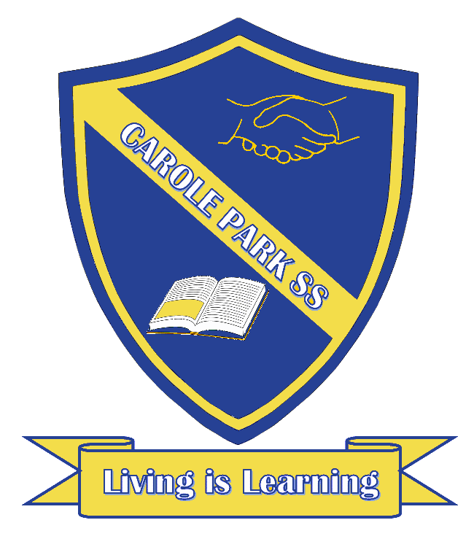
Carole Park State School 2021

This term P/1/2 PJ are learning about…

ENGLISH
This term our class is exploring how a story works.

In Prep we will be exploring imaginative stories and identifying the cover information, main characters and events, including what happens at the beginning and end of the story. We will also link the story’s events to some of our own personal experiences.

In Year 1 we will be exploring imaginative stories, their purpose, comparing different stories and identifying and discussing events, characters and settings, including the beginning, middle and end. We will also link the story’s events to our own personal experiences.

In Year 2 we will be exploring a story’s beginning, middle and end and the importance of a problem in a story. We will recall the events and discuss the feelings of the character, from both literal and inferred information in the story, and link to our own feelings about the events.

MATHS
This term our class is using simple strategies to reason and solve a data inquiry question.

In Prep we will be answering simple data questions, by collecting information, gathering evidence using objects and drawings, using mathematical language and materials, and making simple inferences. We will also be learning about number and measurement.

In Year 1 we will be answering simple data questions by collecting data, creating visual representations, describing mathematical thinking and strategies and reaching conclusions. We will also be learning about number and place value, units of measurement and chance.

In Year 2 we will be choosing a method to gather evidence, describing mathematical thinking and strategies, and collecting, organising and representing data to reach conclusions and make simple inferences. We will also be learning about number and place value, units of measurement and chance.
SCIENCE |  | HASS
This term our class is exploring the living world.  In Prep we will be exploring living things and their needs. We will share and represent observations about the needs of living things and how an environment can affect them.  In Year 1 we will be exploring the habitats of living things, through identifying a range of habitats, predicting and describing changes in habitats, sorting and recording observations and making suggestions to improve the habitat.  In Year 2 we will be exploring how living things grow. We will describe, represent, compare and communicate changes to living things as they grow. |  | This term our class is exploring history and remembering the past.  In Prep we will be identifying, sequencing and sharing important events from our family’s past.  In Year 1 we will be identifying, sequencing and sharing important events from our family’s past and identifying and describing a source that helps you remember the events (photographs, talking, traditions, objects, videos, historic sights etc).  In Year 2 we will be identifying, sequencing and sharing important events from our family’s past and creating a story about the event. We will also be identifying and describing sources that help you remember the event.
DAY | OTHER INFORMATION
MONDAY | Parade at 8.40am in the School Hall

TUESDAY
WEDNESDAY | Music, PE- Mr Lorimer (Swimming from week 4) and Sing and Grow (weeks 4 - 9)
THURSDAY | PE - Mr Lorimer (Swimming from week 4) and Library
FRIDAY | Makerspace/STEAM (Science/Technology/Engineering/Art/Maths)

