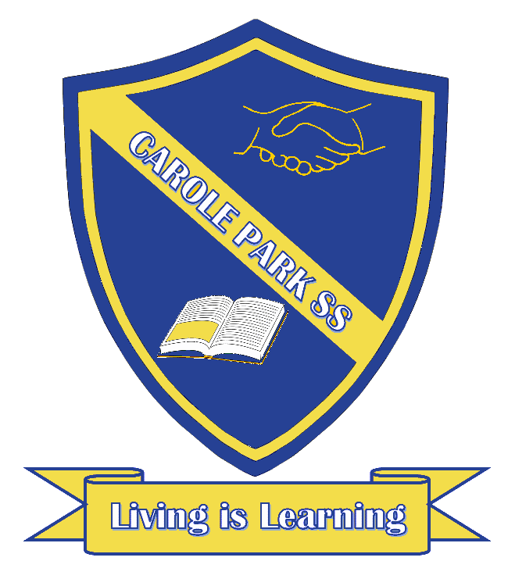
Carole Park State School 2021

This term 6T are learning about…

ENGLISH
This term, students will listen to and read short stories by different authors. They will investigate the ways authors use text structure, language features and strategies to create humorous effects. Students will write a short story about a character that faces a conflict and reflect on the writing process when making and explaining editorial choices.

MATHS
This term in Maths, students will:
- Identify and describe properties of prime and composite numbers, and select and apply mental and written strategies to problems involving all four operations. They will order and compare fractions, add and subtract fractions, calculate the fraction of a given quantity, and solve problems involving the addition and subtraction of fractions.
- Represent the probability of outcomes as a fraction or decimal and conduct chance experiments.
- Investigate and calculate percentage discounts of 10%, 25% and 50% on sale items.
- Solve problems involving the comparison of lengths and areas, and interpret and use timetables.
- Revise different types of data displays, interpret data displays, investigate the similarities and differences between different data displays, identify the purpose and use of different displays, and identify the difference between categorical and numerical data.
SCIENCE |  | HASS
This term in Science, students will explore how sudden geological changes and extreme weather events can affect Earth's surface. They will consider the effects of earthquakes and volcanoes on Earth's surface and how communities are affected by these events. Students will gather, record and interpret data relating to weather and weather events. They will explore the ways in which scientists are assisted by the observations of people from other cultures, including those throughout Asia. They will construct representations of cyclones and evaluate community and personal decisions related to preparation for natural disasters. They investigate how predictions regarding the course of tropical cyclones can be improved by gathering data. |  | In HASS this term, students will examine the key people, events and ideas that led to Australia's Federation and constitution. They will investigate the key institutions, people and processes Australian Government. Students will locate, collect and interpret information from primary sources. They will sequence information about events and the lives of individuals in chronological order. Students will develop arguments, use criteria to make decisions and judgments, work in groups to generate responses to issues and challenges and propose action in response to issues and challenges.
DAY | OTHER INFORMATION
MONDAY | Parade  P.E.

TUESDAY
WEDNESDAY | Music  Library – bring back library books and borrow new books
THURSDAY | P.E.
FRIDAY | P.E.

