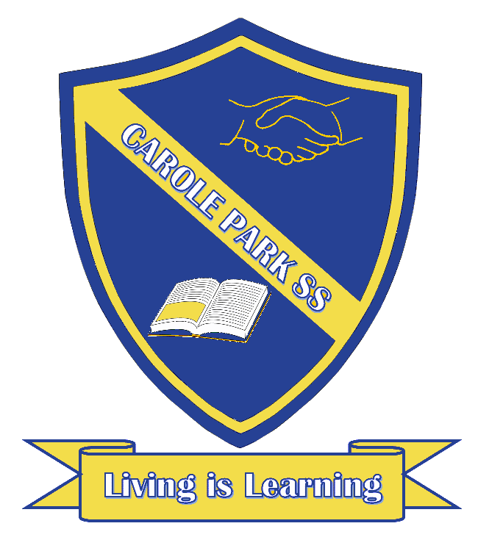
Carole Park State School 2021

This term 5/6 H are learning about…

ENGLISH
“Blast from the past!”! This term students will be exploring a central theme across learning areas that culminates in a time capsule project/event. Before we look to the future, we will examine the past!
In English, our class will read and view extracts from literary texts set in earlier times in order to support them to demonstrate their understanding of how events and characters are created within historical contexts.
They will create a literary text that establishes time and place for the reader, a letter to their future selves that is placed in the time capsule and opened in term 4. Students will analyse and explain their selected language features and text structure. They will also explain how language patterns can be used for emphasis, particularly how they evoke a sense of time and place to their audience.

MATHS
To support our “Blast from the past!” theme further, time is a focus this term. Not just reading the time in both analogue and 24 hour time, but performing calculations with time and applying them to a travel timetable setting. This portion of the term sees students interpret and use timetables, as well as cost information, to determine a travel schedule.
Students are also digging into data. They are interpreting data that is displayed from a variety of tables and graphs, comparing them against differing types of displays including bar graphs, column graphs, pie charts, and picture representations. They are working toward posing questions and collecting their own class data, choosing and justifying the method in which they present their findings. 5/6 H will be required to then investigate the similarities and differences between different data displays, identify the purpose and use of different displays, and identify the difference between categorical and numerical data.

SCIENCE |  | HASS
This is an exciting opportunity for 5/6 H to explore matter. Students will understand that each of solids, liquids and gases have distinct observable properties and behave in different ways. They will investigate changes that can be made to materials and how these changes can be classified as reversible or irreversible. Connecting again to our “Blast from the past!” theme, students will apply their scientific understandings, exploring through traditional practices of evaporation by Indigenous peoples of Australia. Then they will take the hands on role of investigation by using fair testing to answer questions, identify and assess safety risks, make observations and accurately record data to develop explanations for their own evaporation experiment. |  | Students go even deeper into our “Blast from the past!” theme in HASS this term as we explore colonial Australia. 5/6H will learn about what life was like for different groups of people in the colonial period. They examine significant events and people, political and economic developments, social structures, and settlement patterns. This provides opportunities to develop historical understanding through key concepts including sources, continuity and change, cause and effect, perspectives, empathy and significance. This will be an exciting unit for students as they adopt a local perspective and explain why a penal settlement was established at Moreton Bay. This connection will also help support them to propose what effect this could have had on the lives of early Queensland convicts.
DAY | OTHER INFORMATION
MONDAY | Parade, P.E (Swimming begins week 4), just a great day to be in class
TUESDAY | Another great day to be in class
WEDNESDAY | Music, and a great day to be in class
THURSDAY | P.E (Swimming begins week 4), a fantastic day to be in class
FRIDAY | Library borrowing, P.E (Swimming begins week 4), homework due, and another great day to be in class

