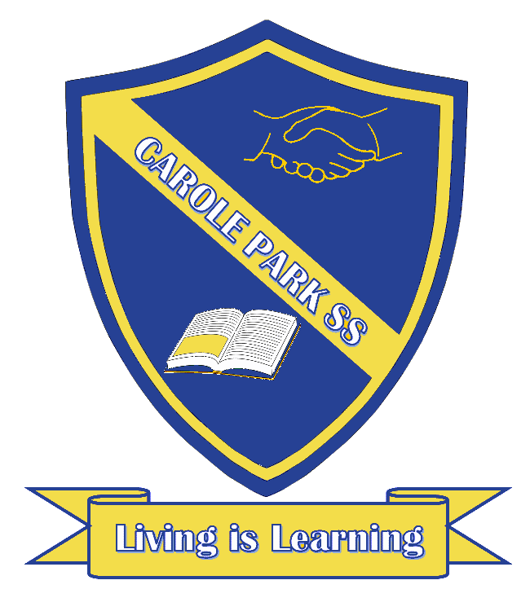
Carole Park State School 2020

This term 4/5B are learning about…

ENGLISH
Persuasive packaging: Students will identify and interpret the persuasive language features and visual elements of a product’s packaging. They will plan, make and create their own package design of an after school snack.

MATHS
Collecting and representing data: Students will define the different methods for data collection and representation, and evaluate their effectiveness. They will pose questions to gather data and construct data displays from given collected data.
Measurement and geometry: Students will identify different forms of symmetry, describe the symmetry and transformation of two-dimensional shapes and identify line and rotational symmetry. They will also interpret information contained in simple maps, identify direction using compass points and grid references to locate landmarks.
Number and algebra: Students will represent and order numbers greater than 10 000, locate and represent fractions and decimals on a number line. They will also use estimation and rounding in calculations.
SCIENCE |  | HASS
Year 4: Students will investigate physical properties of materials and consider how these properties influence the selection of materials for particular purposes. Students will consider how science involves making predictions and how science knowledge helps people to understand the effect of their actions.  Year 5: Students will understand that each of solids, liquids and gases have distinct observable properties and behave in different ways. They will investigate changes that can be made to materials and how these changes can be classified as reversible or irreversible. |  | Year 4: Students will explore the concept of ‘place’ with a focus on Africa and South America. They will investigate how people use, and are influenced by environments and how sustainability is perceived in different ways by different groups.  Year 5: Students will learn about what life was like for different groups of people in the colonial period. They examine significant events and people, political and economic developments, social structures, and settlement patterns.
DAY | OTHER INFORMATION
MONDAY | Homework is handed out (starting Week 4)

TUESDAY

WEDNESDAY
THURSDAY | Swimming (starting Week 4), please pack a swimming bag with swimmers, towel, slip on footwear, spare underwear and googles if required.
FRIDAY | Homework is due  Library borrowing – please bring library bags  Swimming (starting Week 4), please pack a swimming bag with swimmers, towel, slip on footwear, spare underwear and googles if required.

