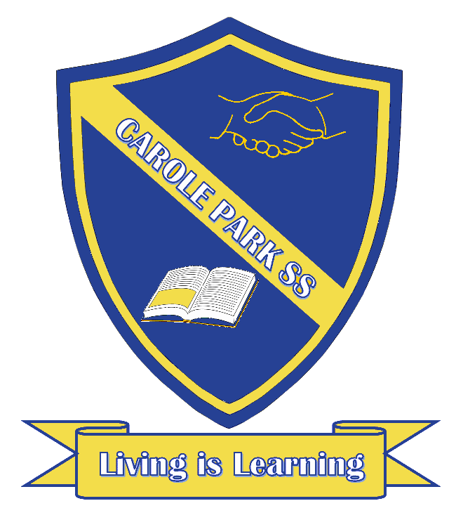
Carole Park State School 2021

This term 3/4R are learning about…

ENGLISH
Student will design and present a breakfast cereal package to an audience of peers.
They will:
- Research ideas.
- Plan and design your breakfast cereal package.
- Write a script to promote your product.
- Rehearse the product promotion with a peer and provide feedback.
- Present the product promotion.

MATHS
In Term One, Year 4 students will recognised, represented, ordered and apply place value to numbers up to tens of thousands. They will also investigate properties of odd and even numbers, recalled multiplication and related division facts (2, 3, 4, 5, 6, 9, and 10).
SCIENCE |  | HASS
In Science, students will investigate what happens to the physical properties (water fastness and smudge resistance) of ochre when different liquids are added. |  | Students will conduct an inquiry to answer the following question: How can people use environments more sustainably?  They will learn how to:  - Compare locations.  - Collect and represent data.  - Analyse and interpret data.  - Propose a solution.
DAY | OTHER INFORMATION
MONDAY | Physical Education

TUESDAY
WEDNESDAY | Music lesson
THURSDAY | Swimming Week 4-8- bring swimming items.
FRIDAY | Swimming Week 4-8- bring swimming items.  Homework- must return homework completed.  Library- must have a library bag in order to borrow.

