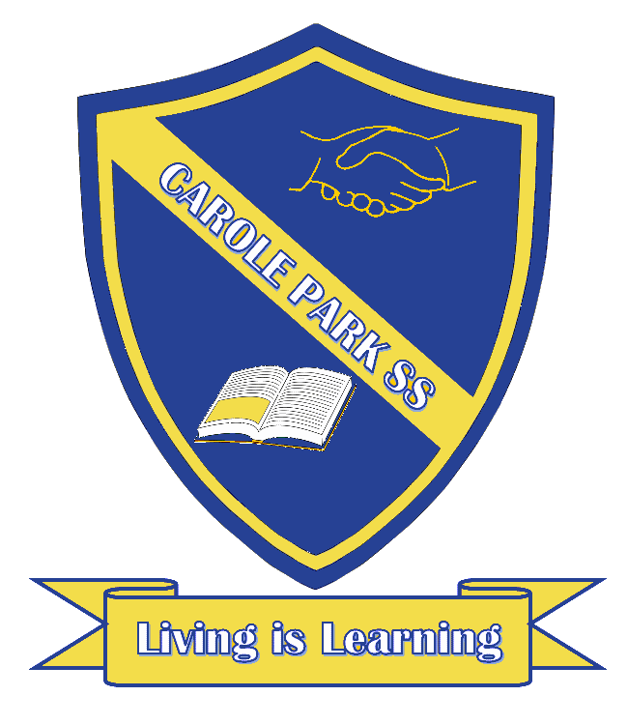
Carole Park State School 2021

This term 2/3 D are learning about…

ENGLISH
This term we are learning to read, write and listen to persuasive texts. The students will be leaning to influence an audience.

MATHS
This term we are learning to order numbers, recognise the connection between addition and subtraction. We will also learn to add and subtract numbers, collect, represent and interpret data from simple chance experiments. We will then investigate measurement.
SCIENCE |  | HASS
This term in Science we will be learning to group living things based on their observable features and how they can be distinguished from non-living things. |  | This term we are learning to answer the question; ‘How and why are ANZAC Day commemorations significant for different groups’?
DAY | OTHER INFORMATION
MONDAY | Parade.  PE; Bring your water bottle and put sunscreen on before you leave home.

TUESDAY
WEDNESDAY | Library; Bring a library bag in you wish to borrow books from the library to take home.  Music
THURSDAY | PE; Bring your water bottle and put sunscreen on before you leave home.  Swimming starts week 4. Thursday and Friday.  - Swimmers; Spare underwear; Towel; Sun safe swim shirt; Pool footwear.
FRIDAY | PE; Bring your water bottle and put sunscreen on before you leave home.  Swimming starts week 4. Thursday and Friday.  Swimmers; Spare underwear; Towel; Sun safe swim shirt.

