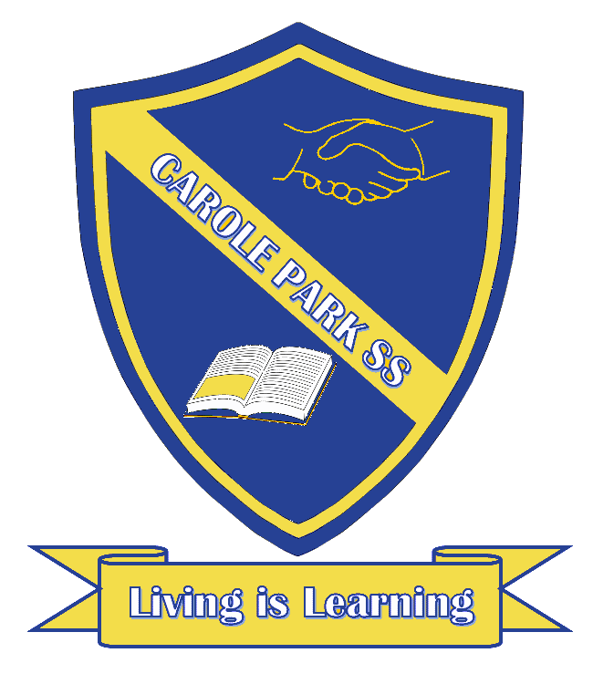
Carole Park State School 2021

This term 1L are learning about…

ENGLISH
- Reading, reading, reading!
- Sentence writing
- Phonics, phonemic awareness and revising concepts about print
- Exploring the purpose, language features, images and text structures of imaginative texts and cultural stories
- Retelling a cultural story

MATHS
- Recognising and representing numbers from 1-100.
- Simple addition and subtraction using a range of strategies
- Identifying and describing 2D shapes and 3D objects
- Representing, ordering and partitioning ‘teen’ numbers
- Skip counting in 2’s, 5’s and 10’s
SCIENCE |  | HASS
- Exploring the properties of everyday materials and how these can be physically changed to suit different purposes. |  | - Identifying, describing and sequencing personal and family events and describing continuities and changes in aspects of daily life over time
DAY | OTHER INFORMATION
MONDAY | PARADE: 8:30 - 9:00 in the school hall. Due to COVID19 restrictions, only students are able to attend.  PE: 12.15 - 12.45 in the hall

TUESDAY
WEDNESDAY | Music: 11.45 - 12.15
THURSDAY | PE Weeks 1- 3: 12.45 - 1.15 in the hall  PE from week 4 onwards: 12.45 -1.15 Swimming at the pool. Please apply sunscreen before school. Students to wear school uniform to school and students change into their swimmers at school. Swimmers must be sun safe and include a sun top with sleeves. Students to supply their own goggles if required.
FRIDAY | PE Weeks 1- 3: 12.45 - 1.15 in the hall  PE from week 4 onwards: 12.45 -1.15 Swimming at the pool. Please apply sunscreen before school. Students to wear school uniform to school and students change into their swimmers at school. Swimmers must be sun safe and include a sun top with sleeves. Students to supply their own goggles if required.

